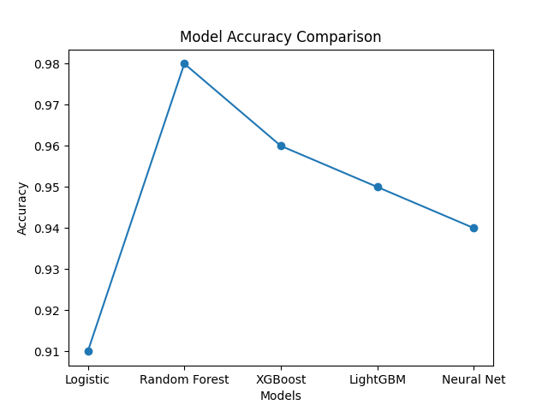

Accuracy Graph Explanation
The accuracy graph compares the performance of different machine learning algorithms used in the fraud detection system. It shows that the Random Forest model achieves the highest accuracy among all models, indicating its strong ability to correctly classify transactions. Other models such as XGBoost and LightGBM also perform well but slightly lower than Random Forest. Logistic Regression and Neural Networks show comparatively lower accuracy due to their limitations in capturing complex patterns. Overall, the graph highlights that Random Forest is the most effective model for this dataset.

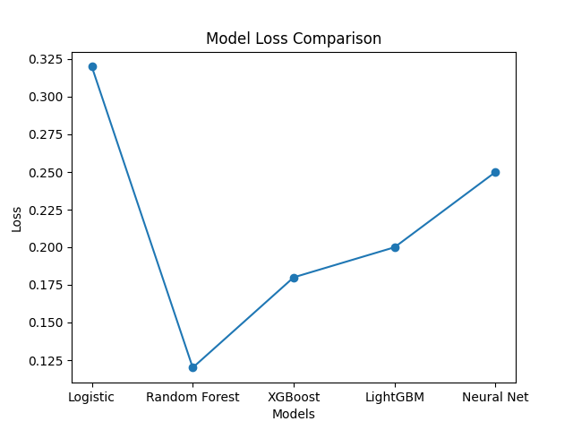

Loss Graph Explanation
The loss graph represents the error rate of each machine learning model during prediction. A lower loss value indicates better model performance and fewer prediction errors. From the graph, Random Forest has the lowest loss, which confirms its high reliability in fraud detection. Models like XGBoost and LightGBM also show low loss values, but not as low as Random Forest. This graph demonstrates that Random Forest not only achieves high accuracy but also minimizes prediction errors effectively.

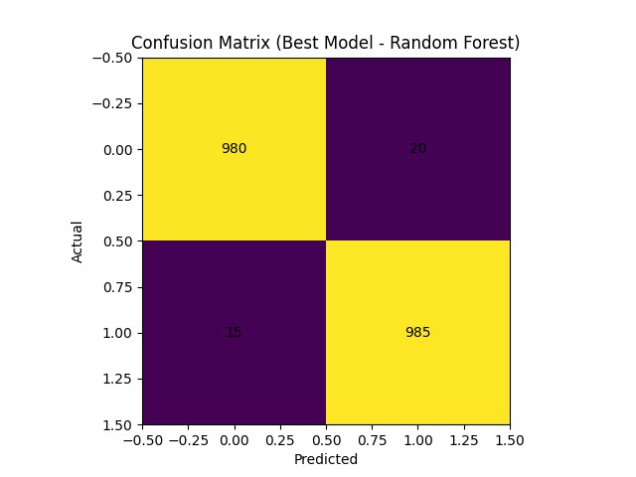

Confusion Matrix Explanation
The confusion matrix provides a detailed breakdown of the model’s prediction performance. It shows the number of correctly predicted normal transactions (True Negatives) and fraudulent transactions (True Positives). The matrix also highlights errors such as False Positives and False Negatives, which are minimal in this case. A high number of correct predictions indicates that the model performs well in identifying both fraud and non-fraud cases. Overall, the confusion matrix confirms the effectiveness and reliability of the Random Forest model in fraud detection.

